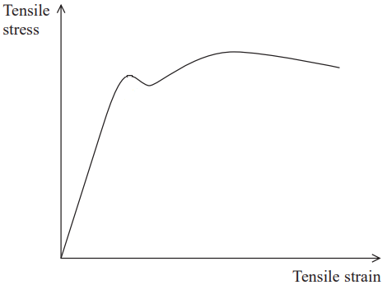**Q1**) a) using the graph on the right:

Draw and label point **A** for limit of proportionality  
 Draw and label point **B** for Elastic limit  
 Draw and label point **C** for Yield point  
 Draw and label point **D** for Ultimate tensile stress  
 Draw and label point **E** for Breaking point

b) On the same graph draw a second curve representing a less stiff material than the one in the graph

**Q2**) The graph on the right represents the properties of a rubber band,

a) calculate the elasticity constant for the rubber band

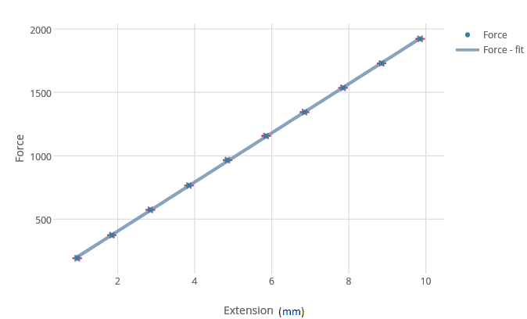

b) calculate the work done on the rubber band

c) assuming the rubber band has a mass of 6g, what would be its maximum velocity *hint: $KE=1/2mv²$*

**Q3**) What is the amount of elongation that occurs on a (2m) long steel wire with diameter of (1mm) if a mass of   
(8 kg) is attached to its end (g = 10m/s² )? Young modulus for steel is (200 ×109 N/m2 ).

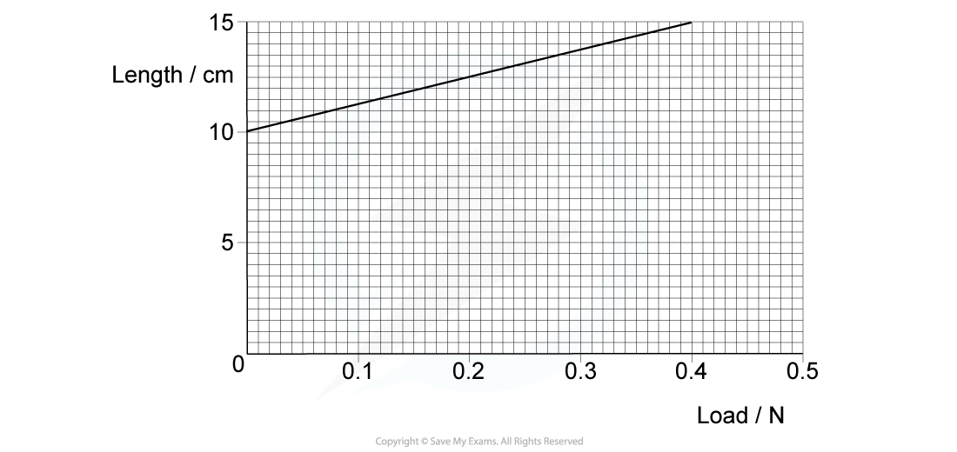**Q4**) a spring was stretched using a certain load,   
 a) determine the spring’s constant (*k*)

b) Determine the work done stretching the spring